Data Analytics (DA)
Module -3
MySQL Assignment 2 - Querying Data
Task
Dataset Description:
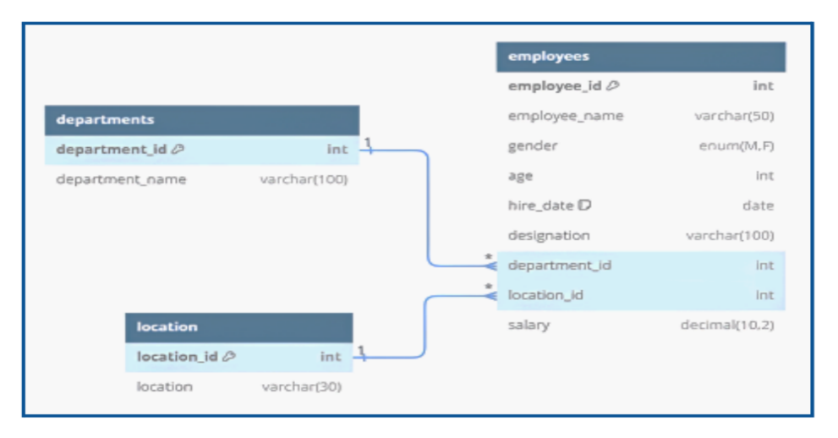

● Table: Departments
- Attributes:
- department_id – Primary Key
- department_name
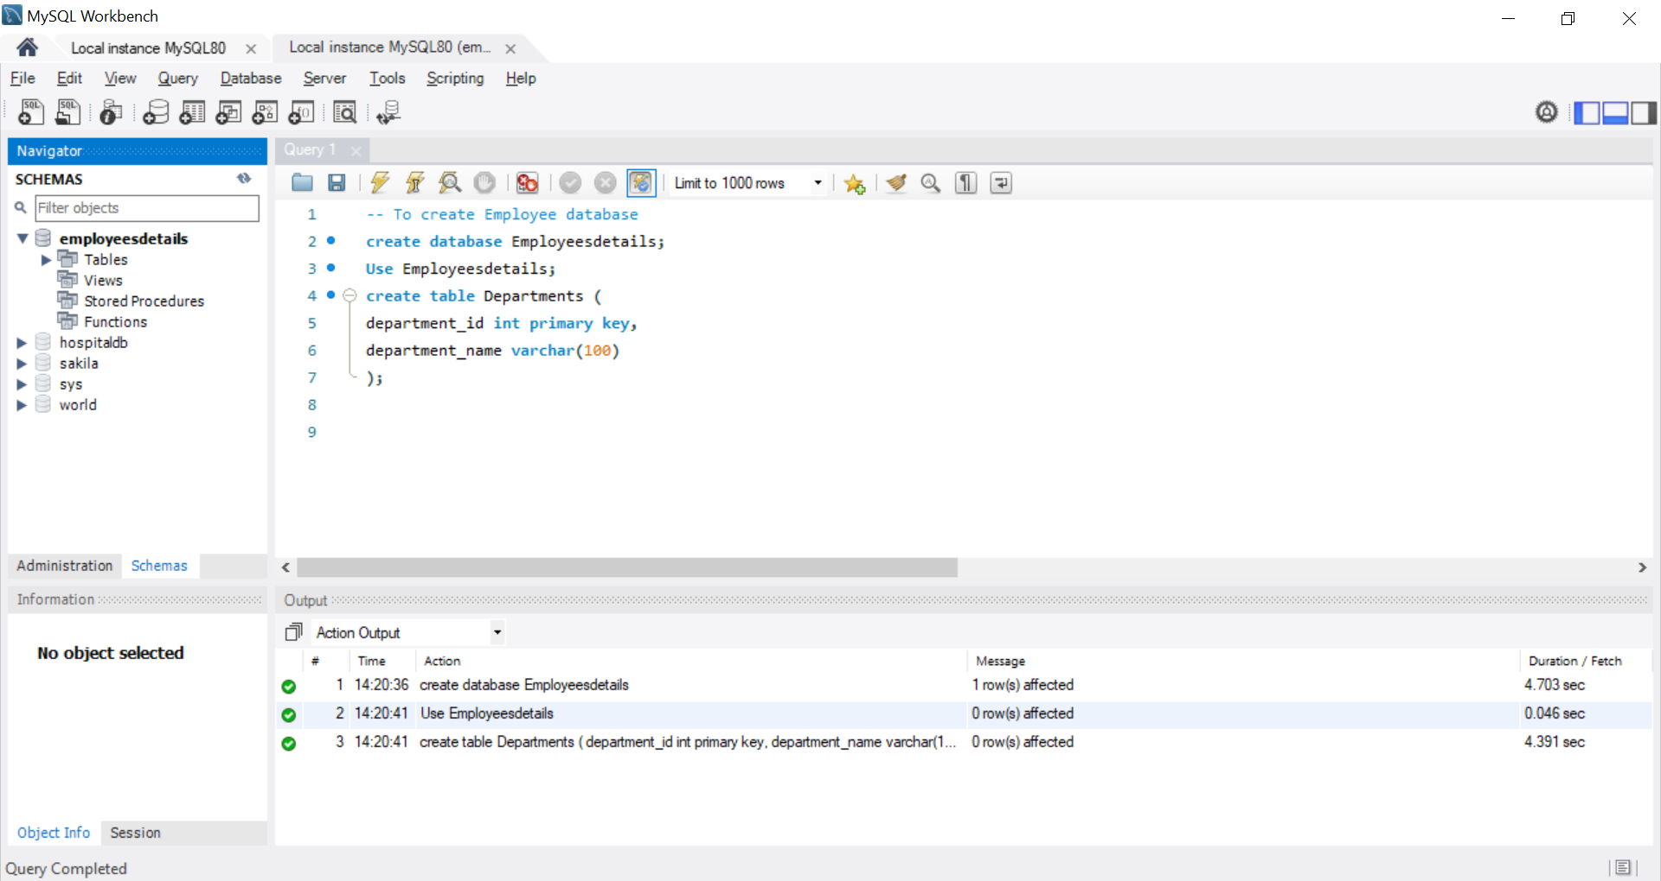
● Table: Location
- Attributes:
- location_id – Primary Key
- location_name
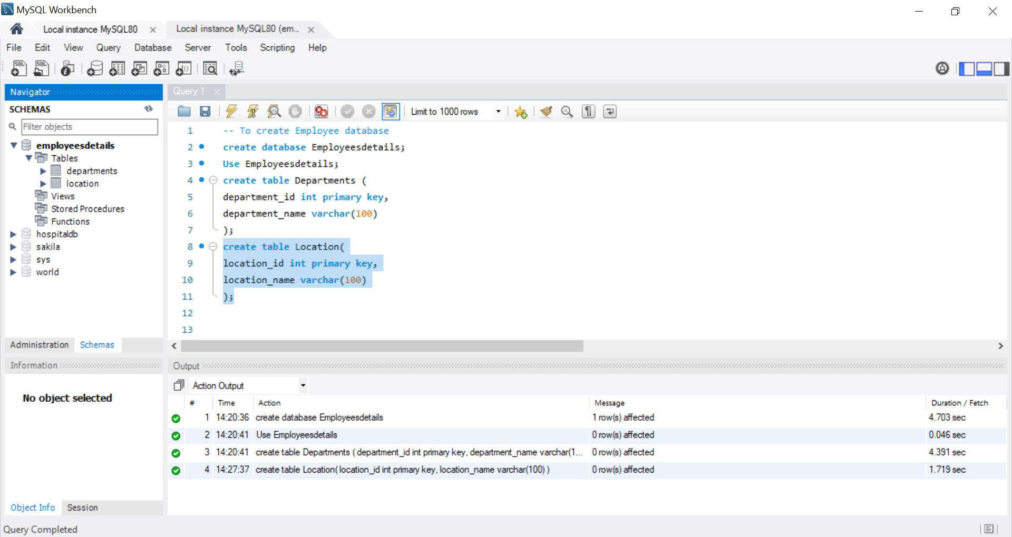
● Table: Employees
- Attributes:
- employee_id – Primary Key
- Employee_name
- Gender
- Age
- Hire_date
- Designation
- Salary
- department_id – Foreign Key referencing department(department_id)
- location_id—Foreign Key referencing location(location_id)
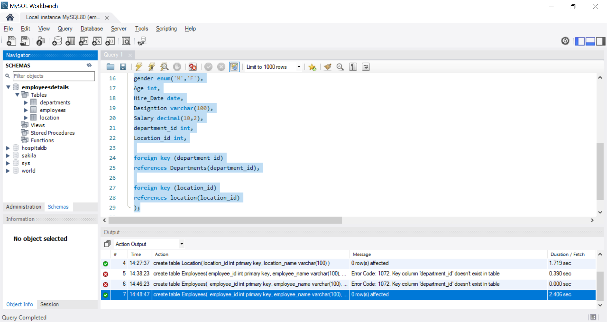

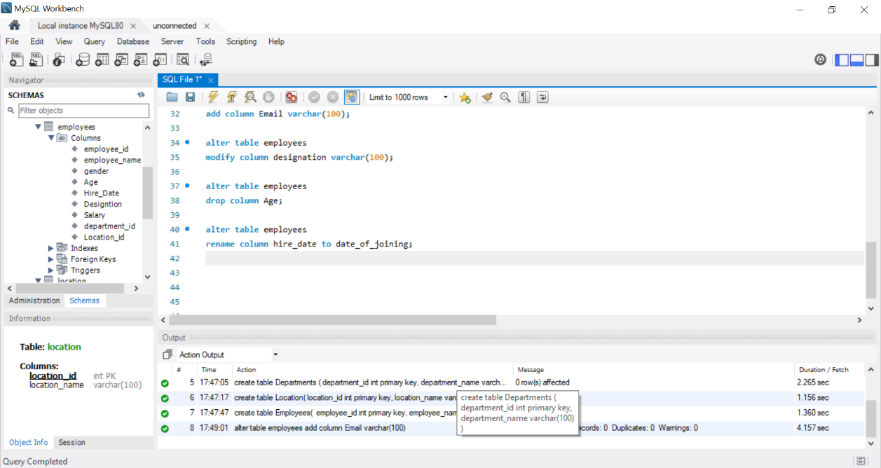
OUTPUT:
Q:Problem Statement:
As a Data Analyst, you will continue working with the Employee Database created in the previous assignment. The database already contains the required tables, relationships, and constraints.
Use this DML insert code, DML Insertion- Employee Data, to populate the tables
Insert departments Data:
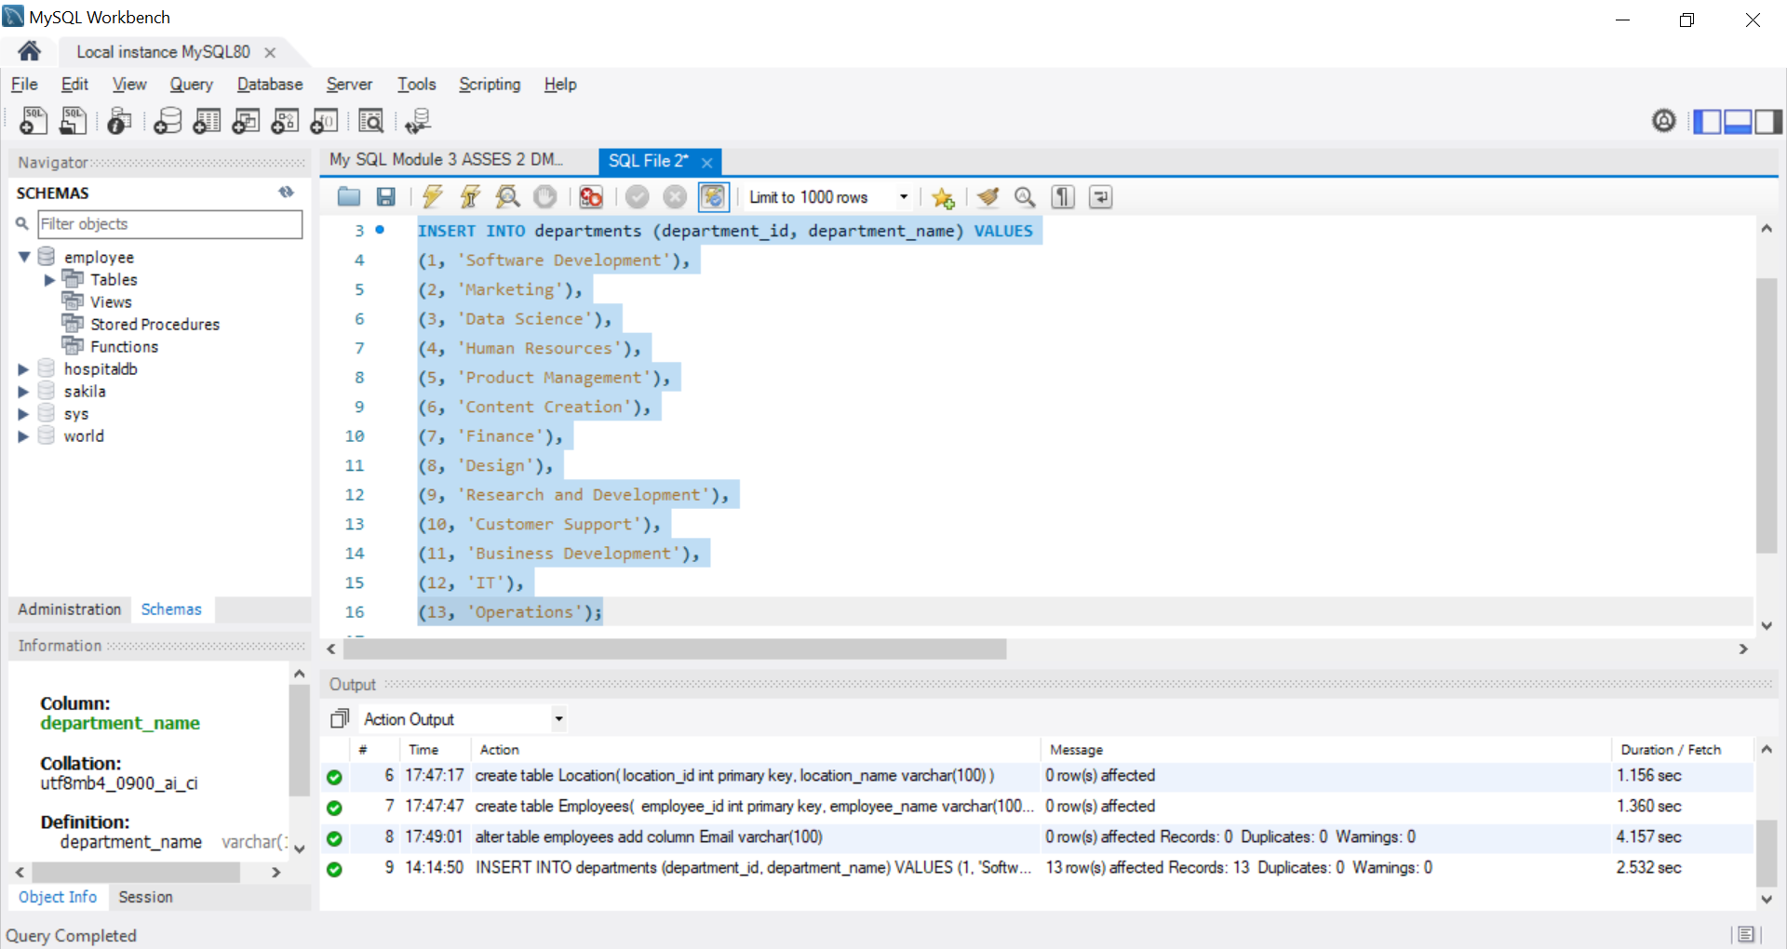

Inserted Data OUTPUT:
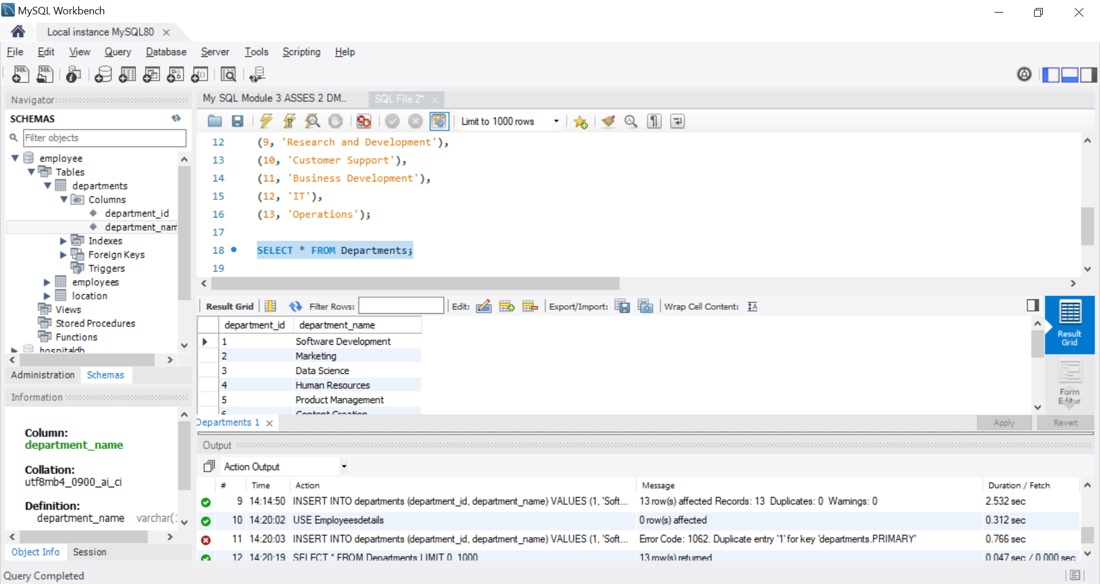
Insert Location Data:
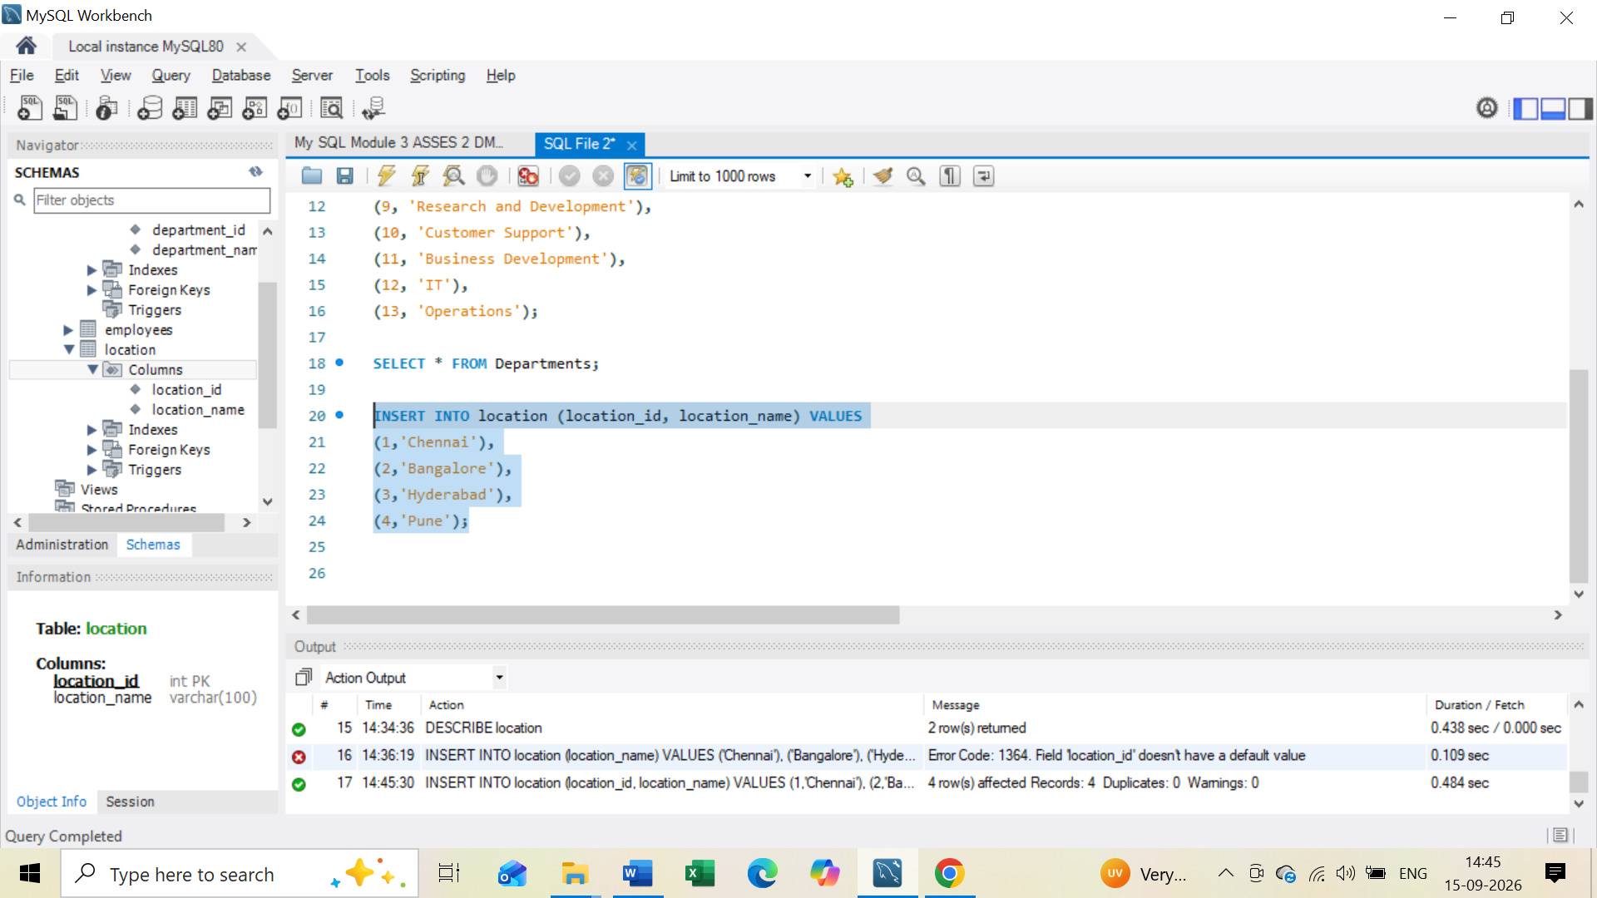

Inserted Location Data OUTPUT:
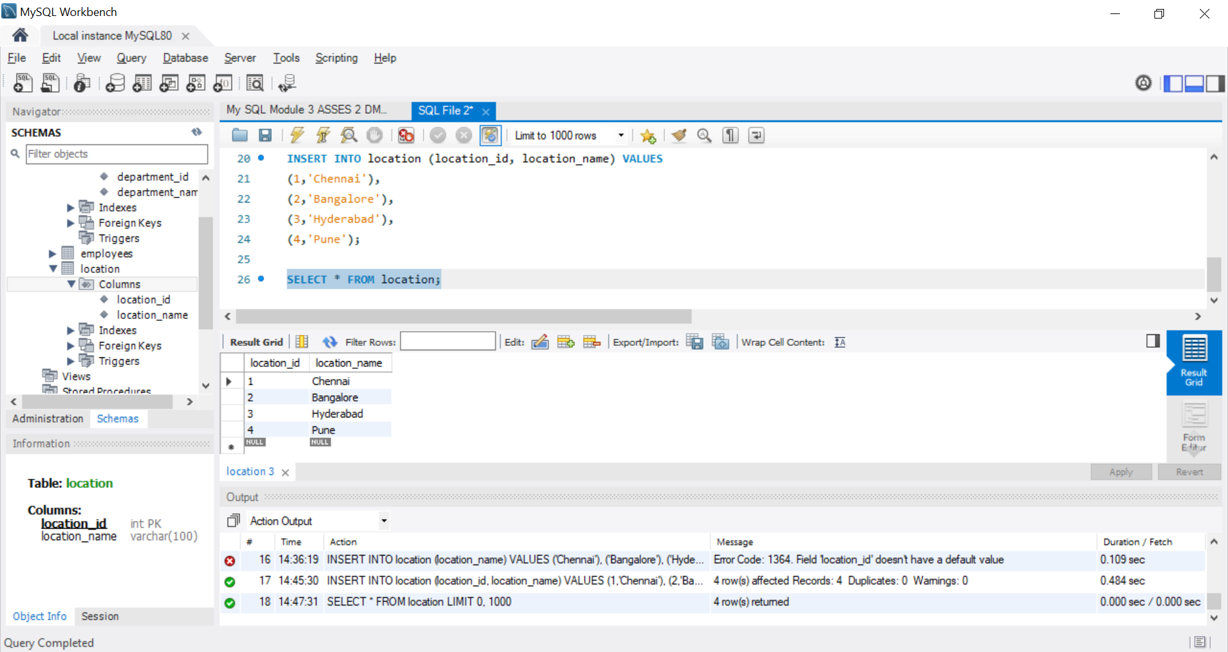
Insert Location Datas:
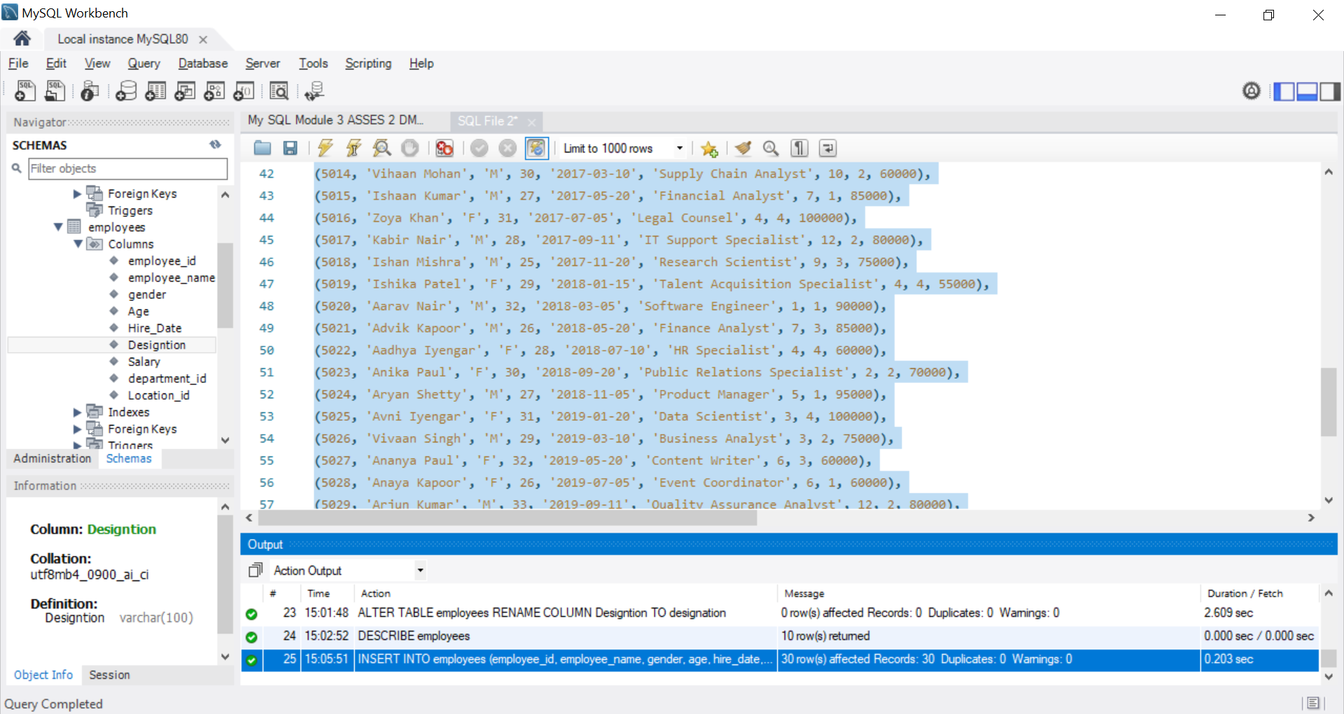

Inserted Employee Data OUTPUT:
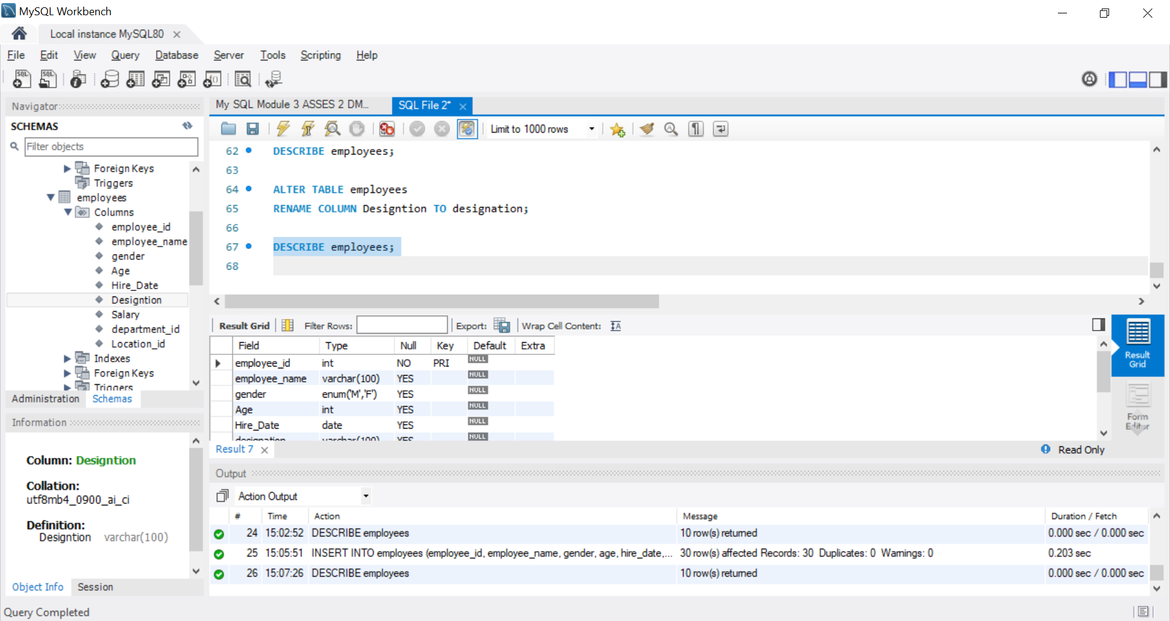
Tasks
Clause & Operators:
1. DISTINCT VALUES:
● A query to retrieve distinct salaries from the Employees table.
Syntax:
SELECT DISTINCT Salary
FROM Employees;

OUTPUT:
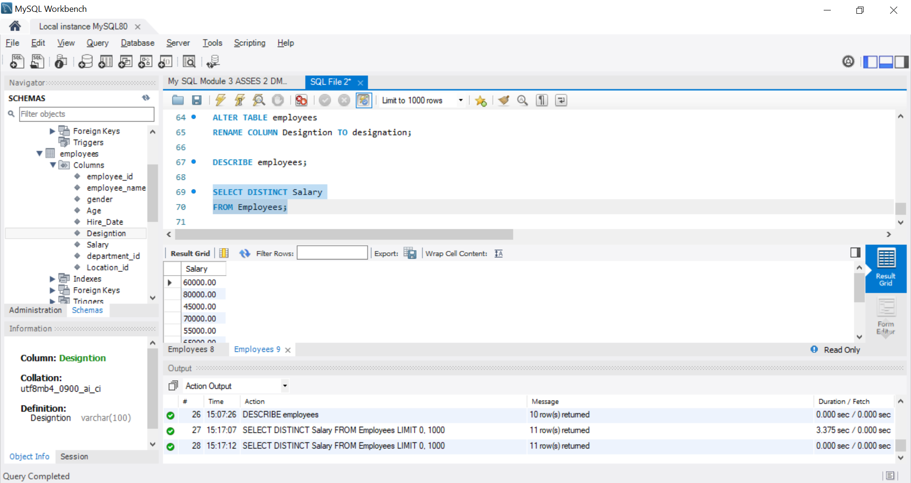
2. ALIAS (AS):
● Provide aliases for the "age" and "salary" columns as "Employee_Age" and
"Employee_Salary", respectively.
Syntax:
SELECT
Age AS Employee_Age,
Salary AS Employee_Salary
FROM Employees;

OUTPUT:
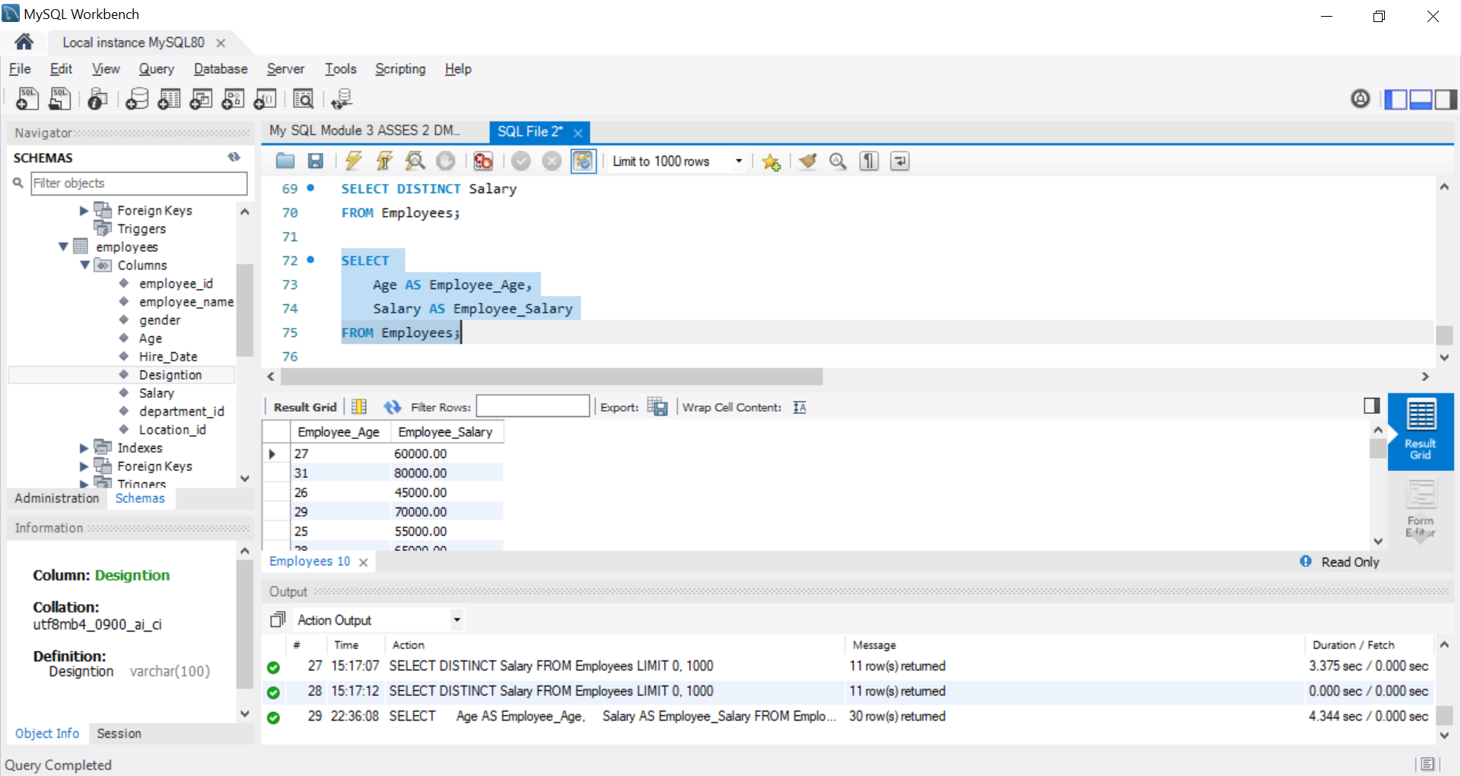
3. WHERE CLAUSE & OPERATORS:
● Retrieve employees with a salary greater than ₹50000 and hired before
2016-01-01.
- Use the WHERE clause with both conditions:
Syntax:
SELECT *
FROM Employees
WHERE Salary > 50000
AND Hire_Date < '2016-01-01';

OUTPUT
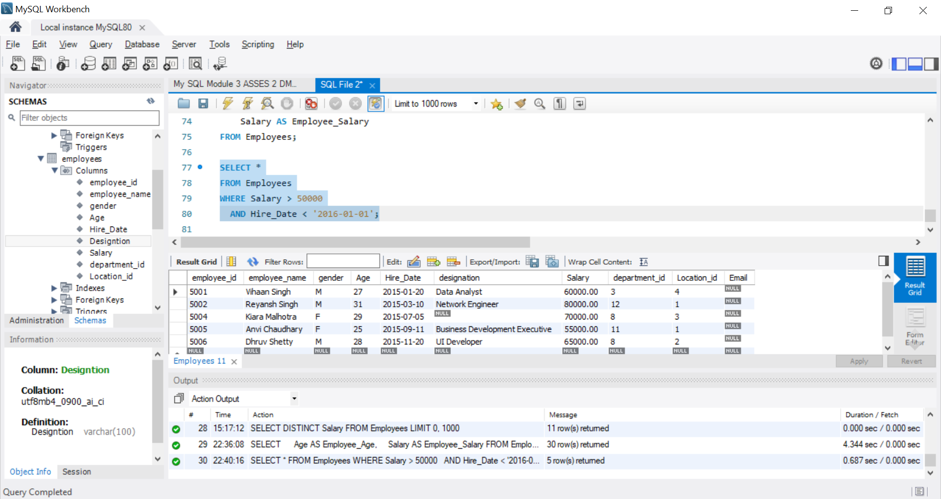
● Find the employee whose designation is missing and fill it with "Data
Scientist".
- Find the employee with missing designation
Syntax:
SELECT employee_id, employee_name, designation
FROM Employees
WHERE designation IS NULL;

OUTPUT
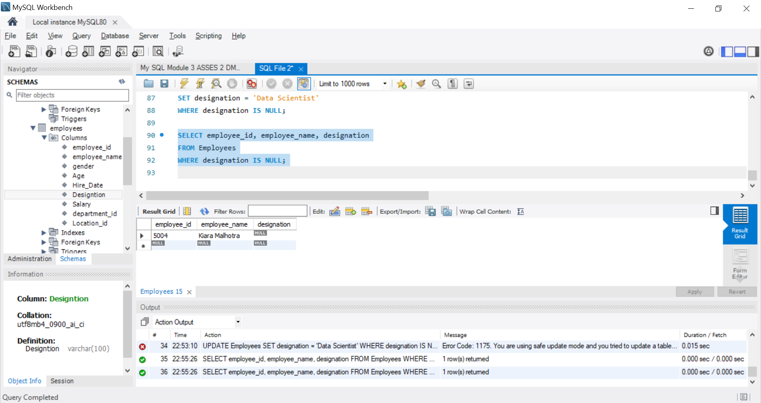
- Fill the missing designation with "Data Scientist"
- update using the primary key

Syntax:
UPDATE Employees
SET designation = 'Data Scientist'
WHERE employee_id = 5004;

Updated:
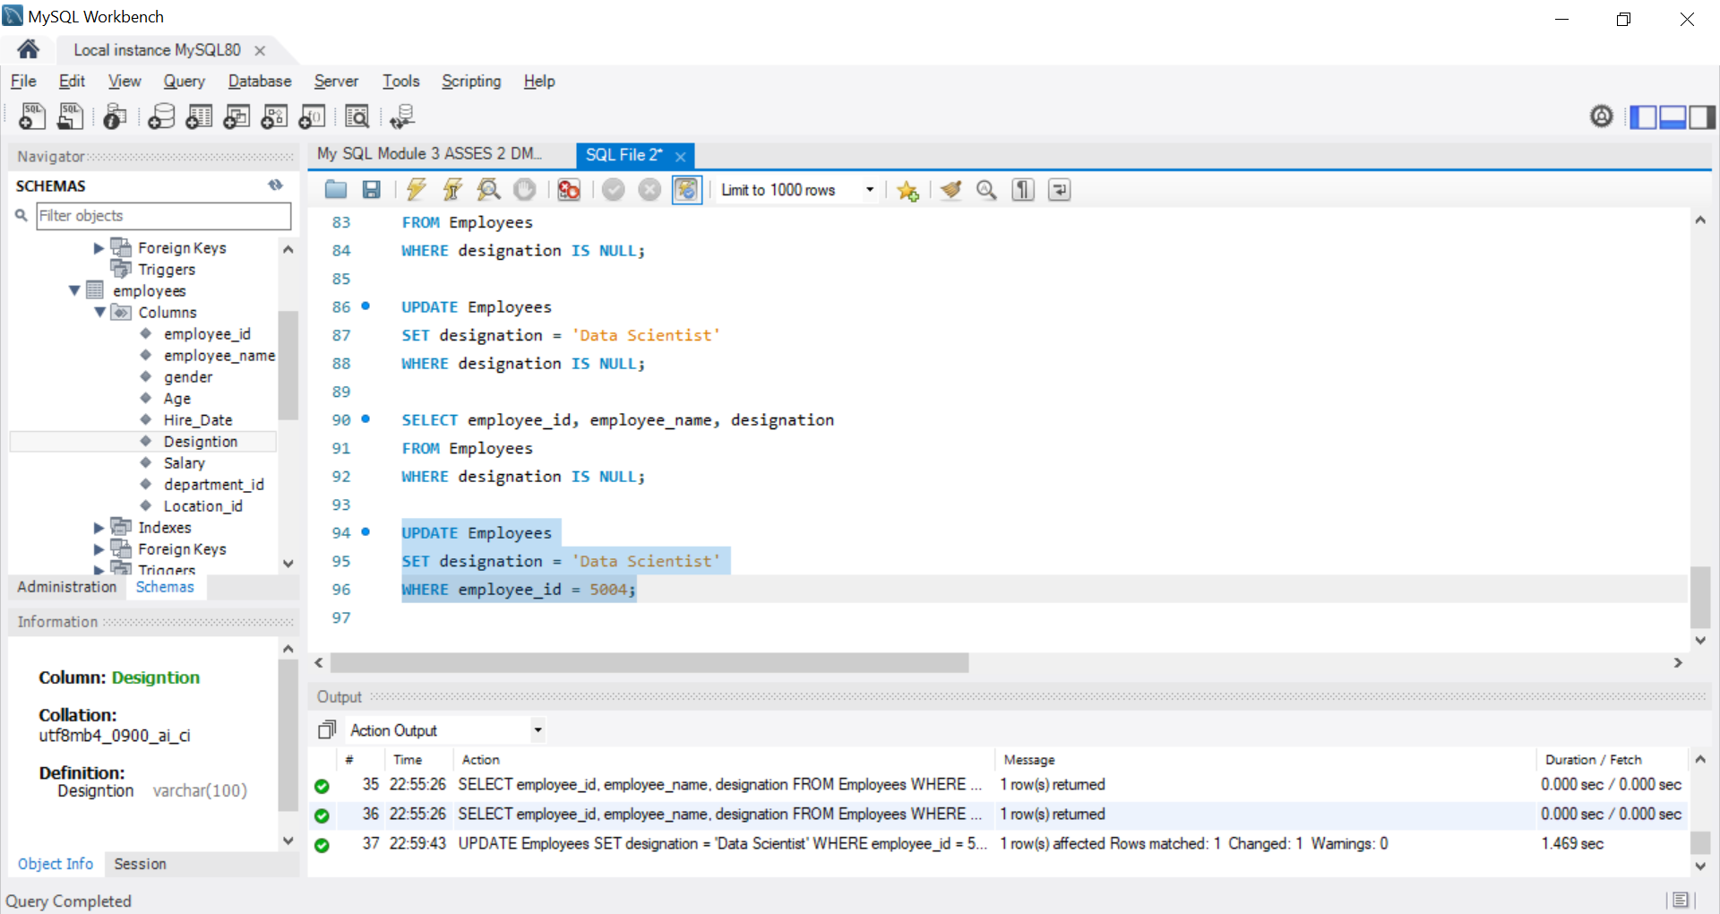
Syntax:
SELECT employee_id, employee_name, designation
FROM Employees
WHERE employee_id = 5004;

OUTPUT
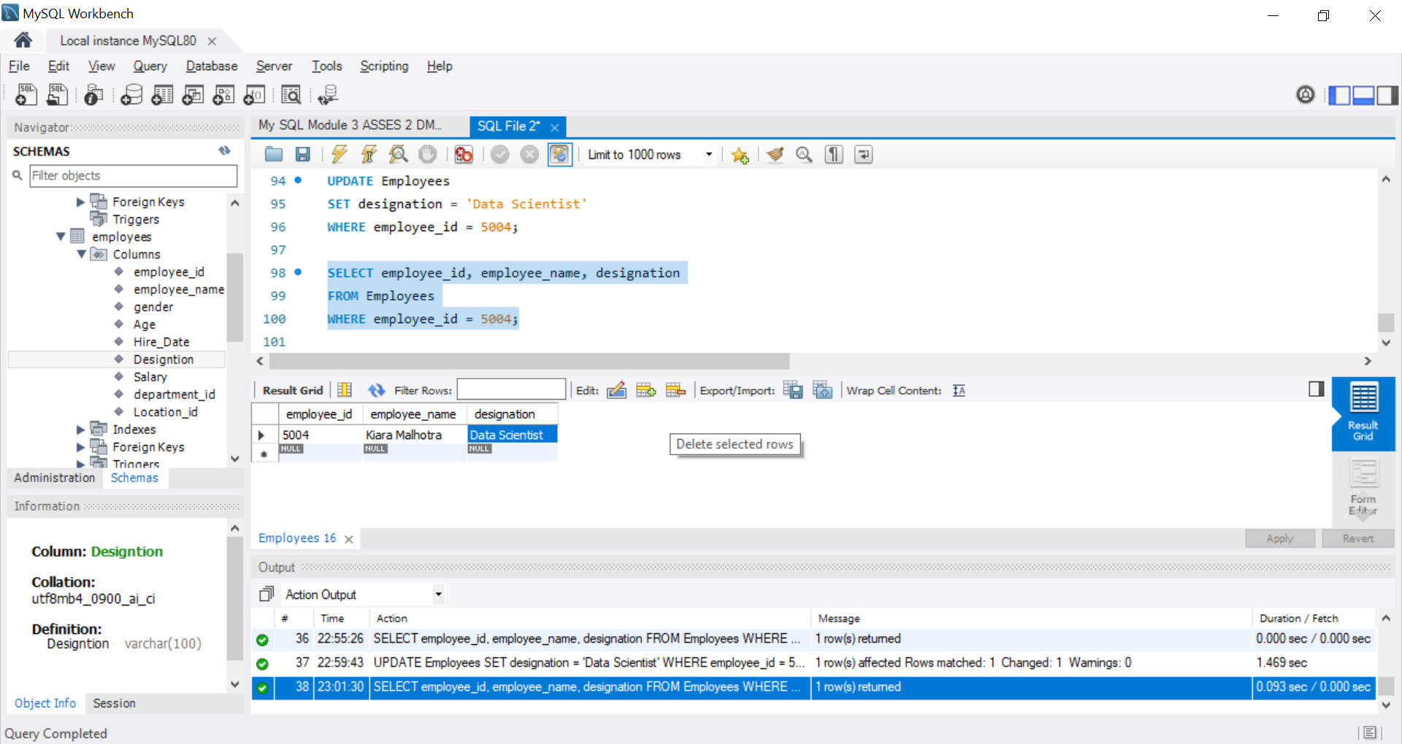

Sorting And Grouping Data:
1. ORDER BY:
● Find employees sorted by department ID in ascending order and salary in
descending order.
- Use ORDER BY with two columns:
Syntax:
SELECT *
FROM Employees
ORDER BY department_id ASC,
Salary DESC;

OUTPUT:
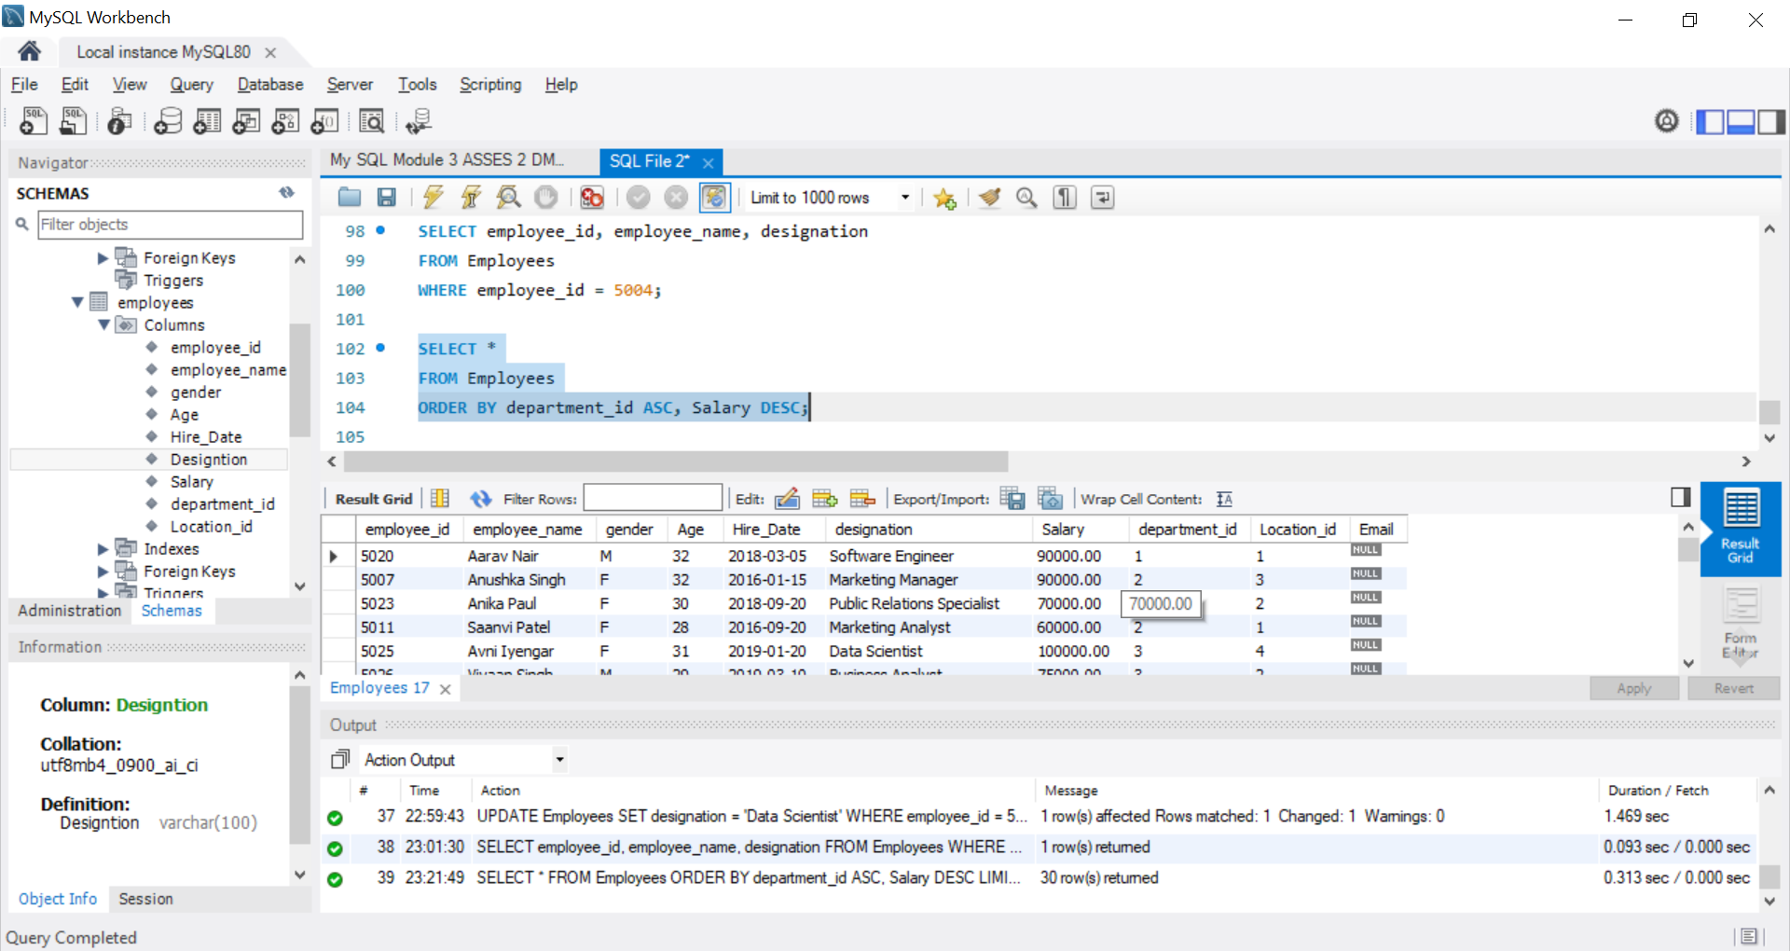
2. LIMIT:
● Display the first 5 employees hired in the year 2018.
Syntax:
SELECT *
FROM Employees
WHERE Hire_Date >= '2018-01-01'
AND Hire_Date < '2019-01-01'
ORDER BY Hire_Date ASC
LIMIT 5;

OUTPUT:
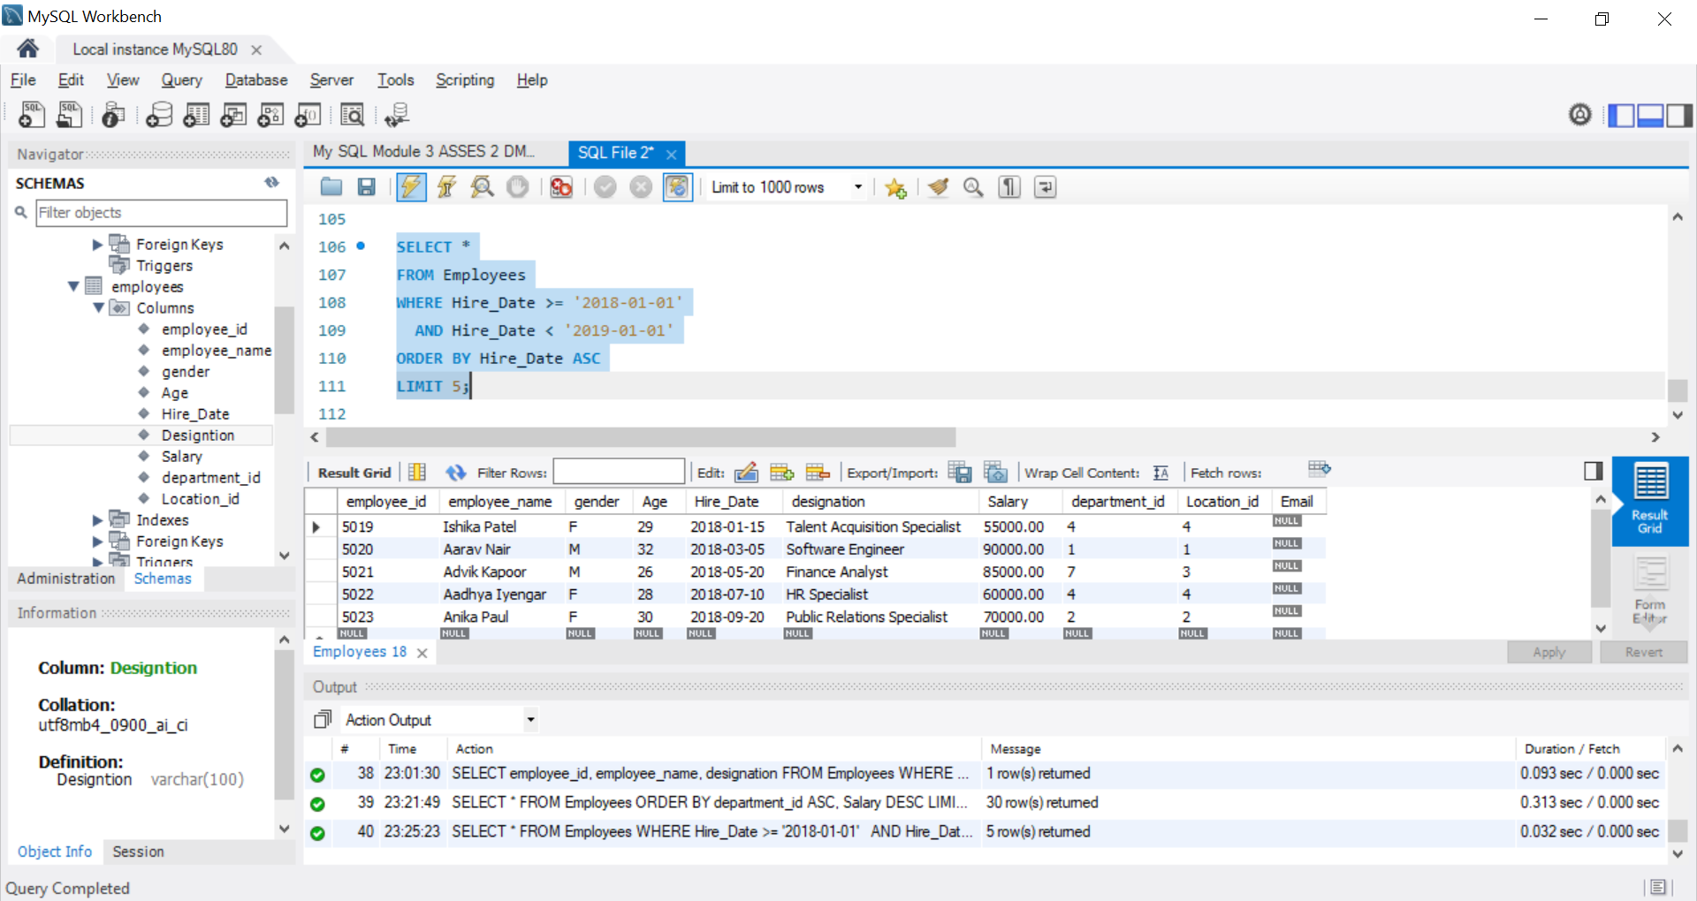
3. AGGREGATE FUNCTIONS:
● Calculate the sum of all salaries in the Finance department.
use the SUM() aggregate function.
- Departments table contains department_name = 'Finance'
OUTPUT:
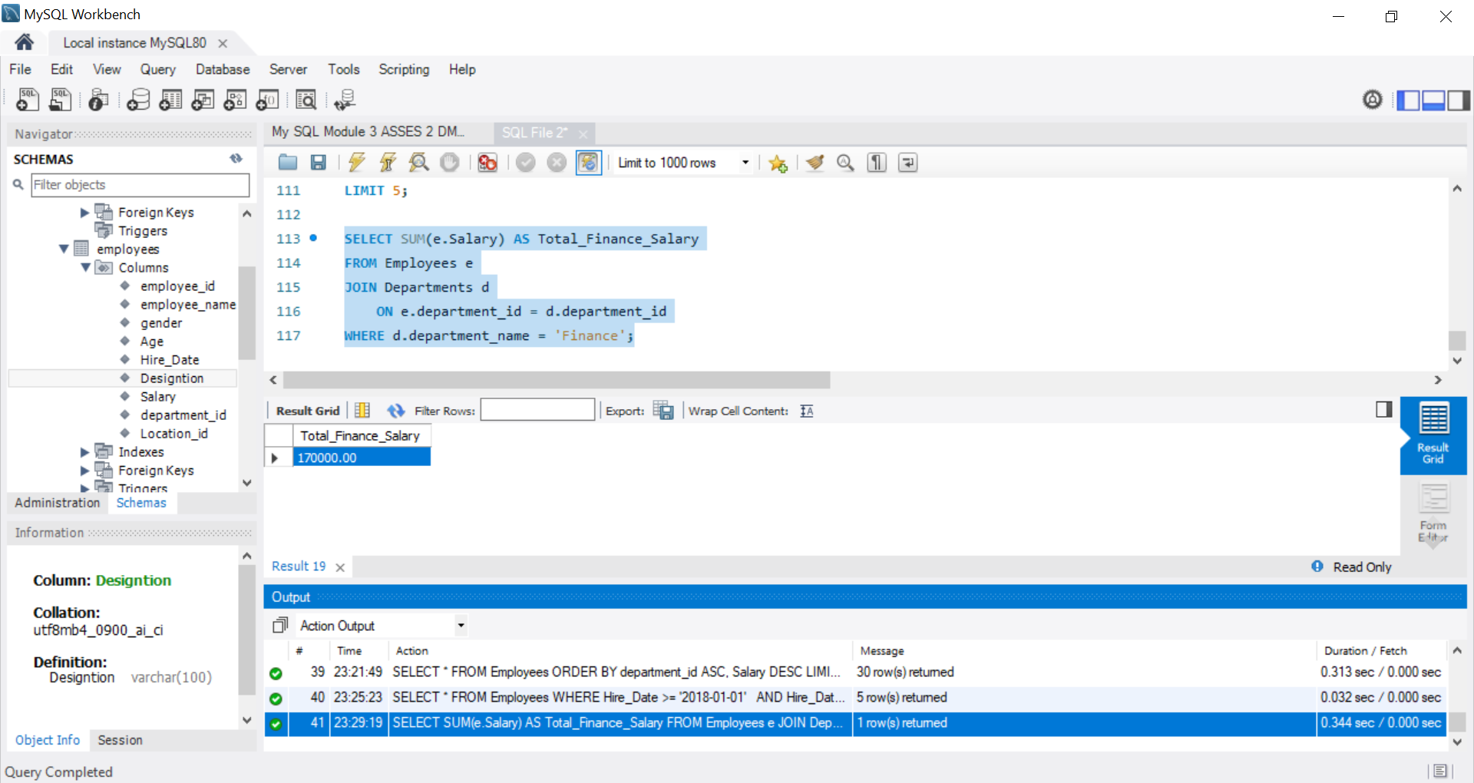
● Find the minimum age among all employees.
Syntax:
SELECT MIN(Age) AS Minimum_Age
FROM Employees;
OUTPUT:
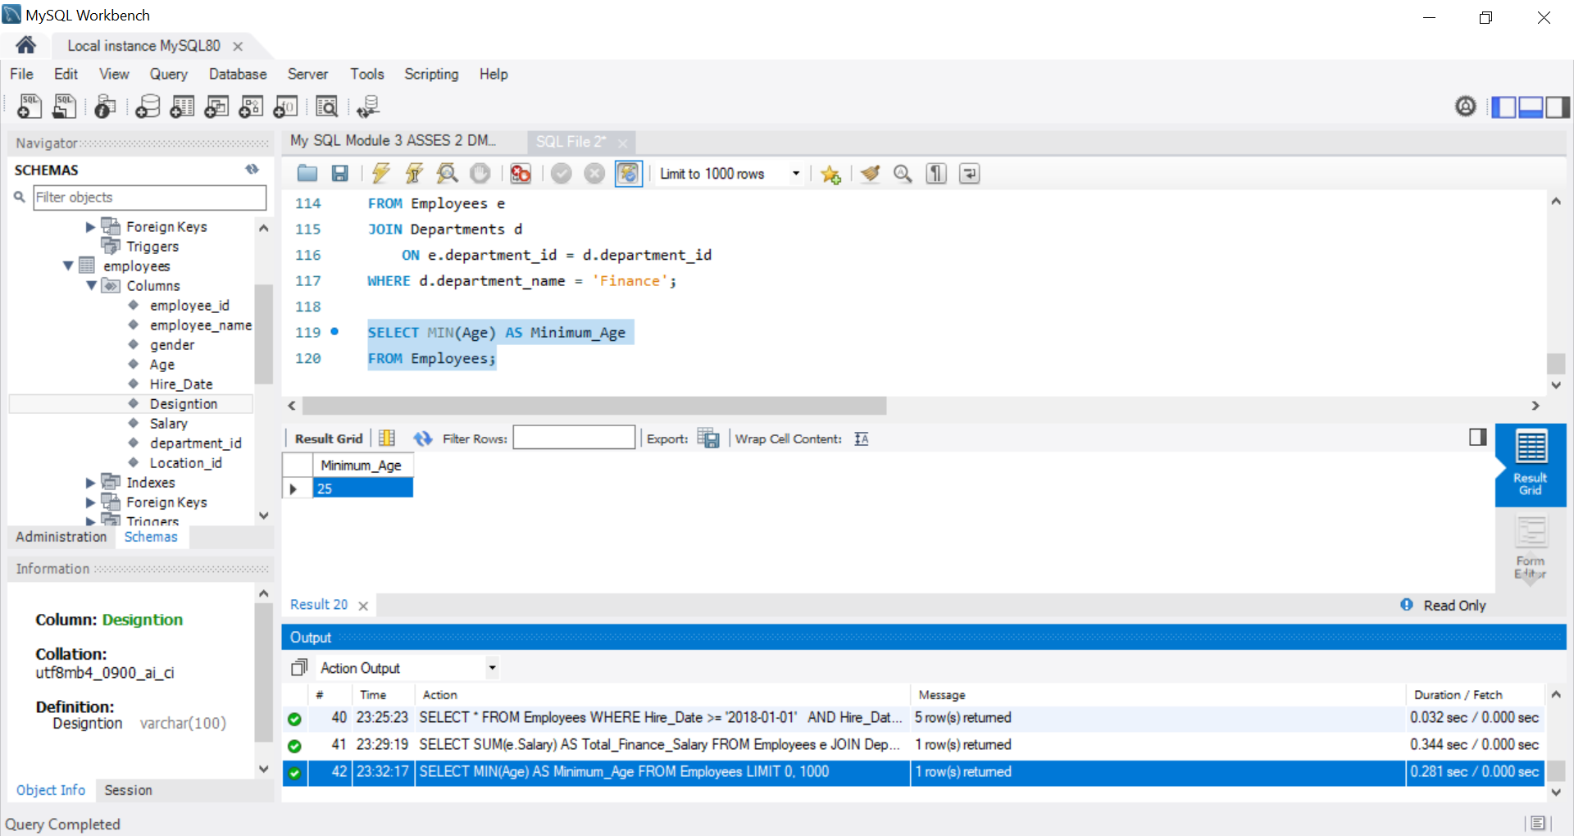
4. GROUP BY:
● List the maximum salary for each location.
- Employees table has Location_id, and the location names are stored in the location table:
Syntax:
SELECT l.location_name,
MAX(e.Salary) AS Maximum_Salary
FROM Employees e
JOIN location l
ON e.Location_id = l.location_id
GROUP BY l.location_name;
OUTPUT
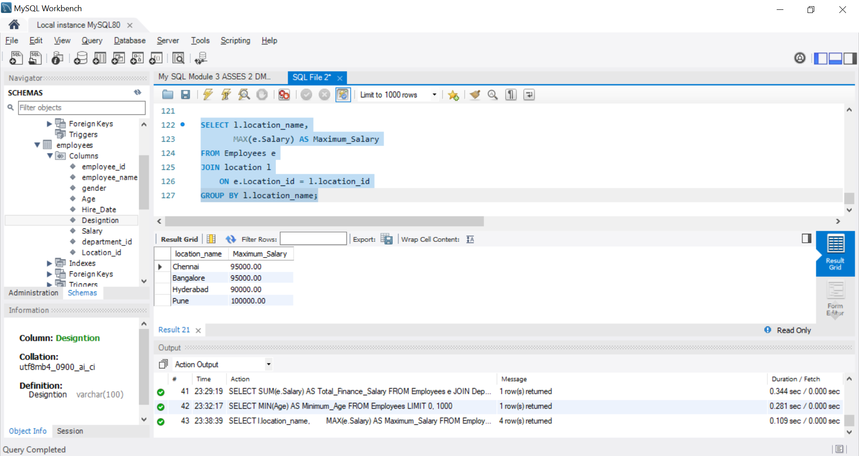

● Calculate the average salary for each designation containing the word 'Analyst'.
- Use LIKE '%Analyst%'
Syntax:
SELECT designation,
AVG(Salary) AS Average_Salary
FROM Employees
WHERE designation LIKE '%Analyst%'
GROUP BY designation;
OUTPUT:
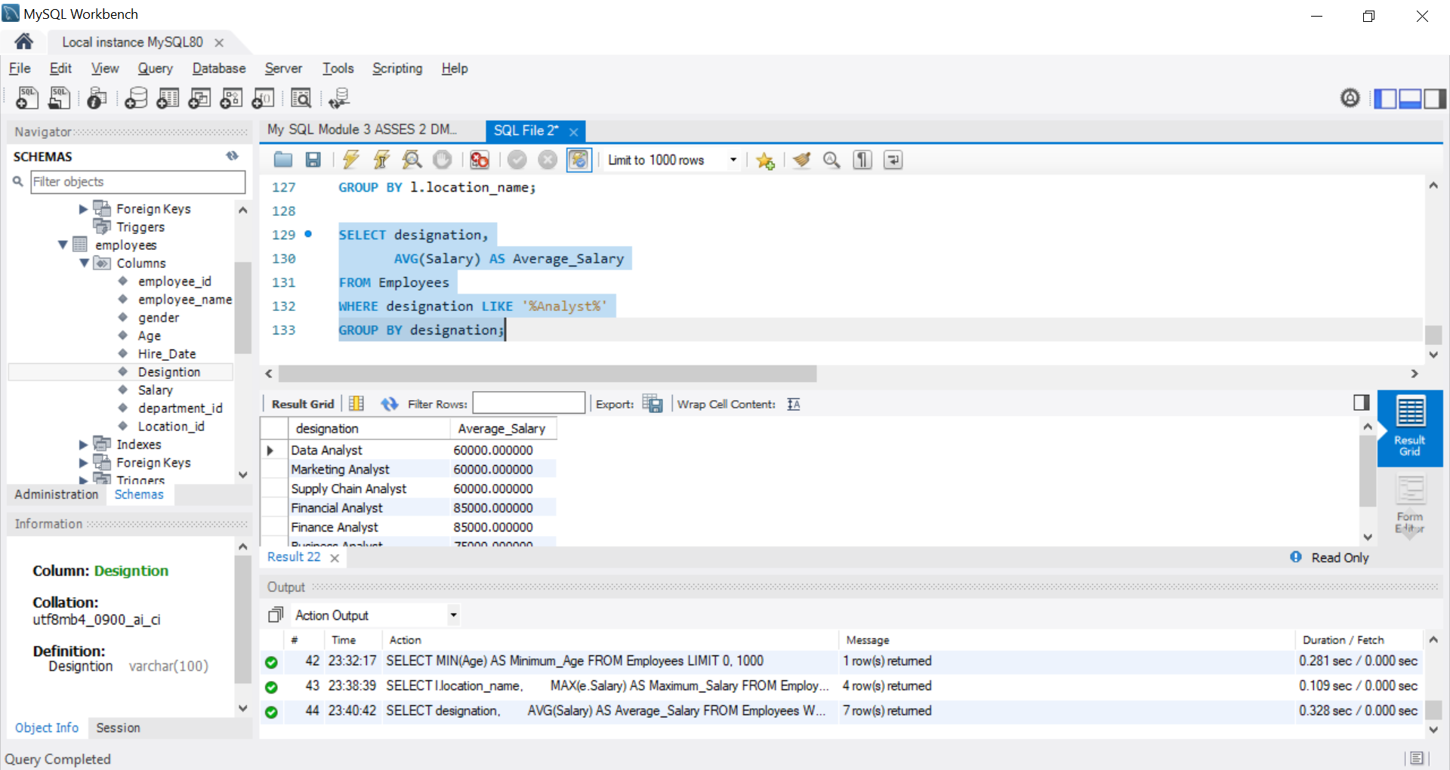
5. HAVING:
● Find departments with less than 3 employees.
Syntax:
SELECT department_id,
COUNT(*) AS Employee_Count
FROM Employees
GROUP BY department_id
HAVING COUNT(*)GROUP BY < 3;

OUTPUT:
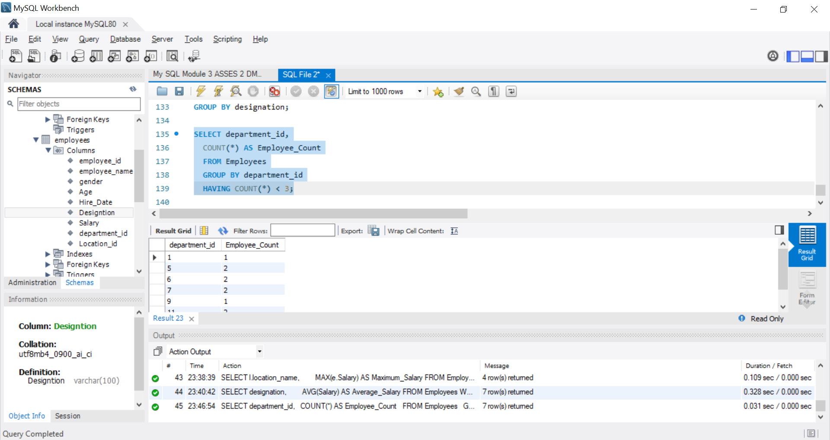
● Find locations with female employees whose average age is below 30.
Syntax:
SELECT Location_id,
AVG(Age) AS Average_Age
FROM Employees
WHERE Gender = 'F'
GROUP BY Location_id
HAVING AVG(Age) < 30;
OUTPUT:
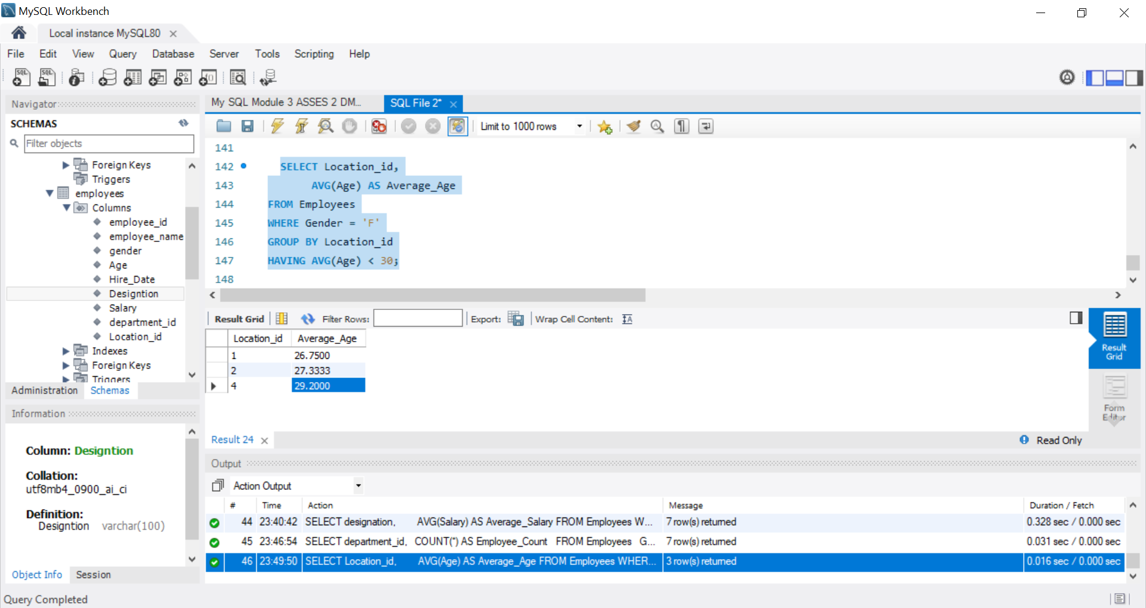

Joins:
1. INNER JOIN:
● List employee names, their designations, and department names where
employees are assigned to a department.
- For an INNER JOIN, connect the Employees table with the Departments table using department_id:
Syntax:
SELECT
e.employee_name,
e.designation,
d.department_name
FROM Employees e
INNER JOIN Departments d
ON e.department_id = d.department_id;

OUTPUT:
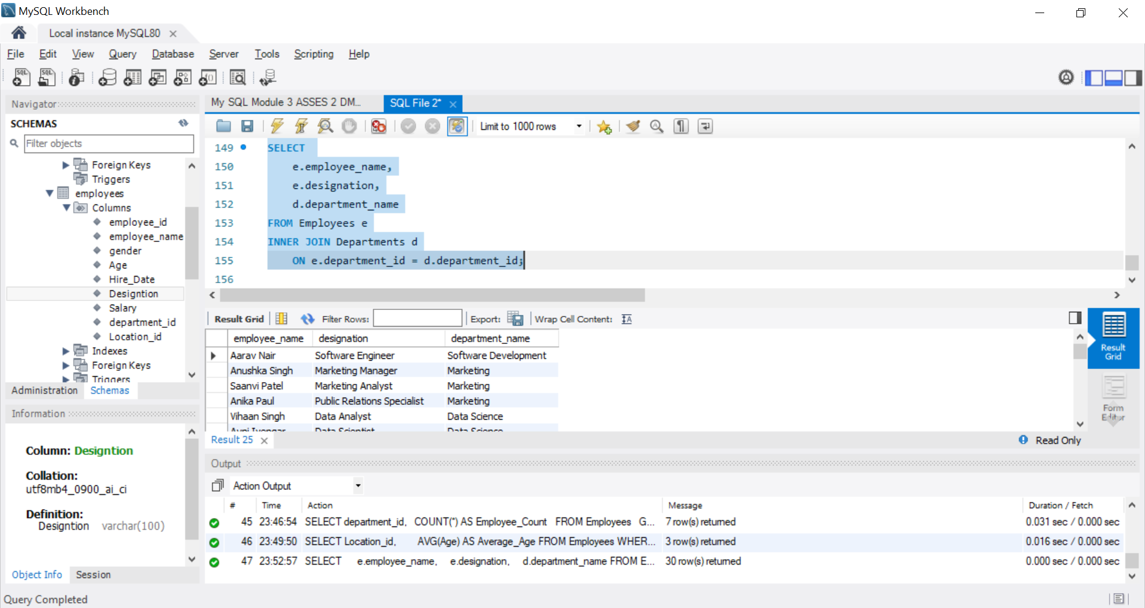
2. LEFT JOIN:
● List all departments along with the total number of employees in each
department, including departments with no employees.
- For a LEFT JOIN, start with the Departments table so that all departments are included, even when they have no employees.

Syntax:
SELECT
d.department_id,
d.department_name,
COUNT(e.employee_id) AS Total_Employees
FROM Departments d
LEFT JOIN Employees e
ON d.department_id = e.department_id
GROUP BY d.department_id, d.department_name;

OUTPUT:
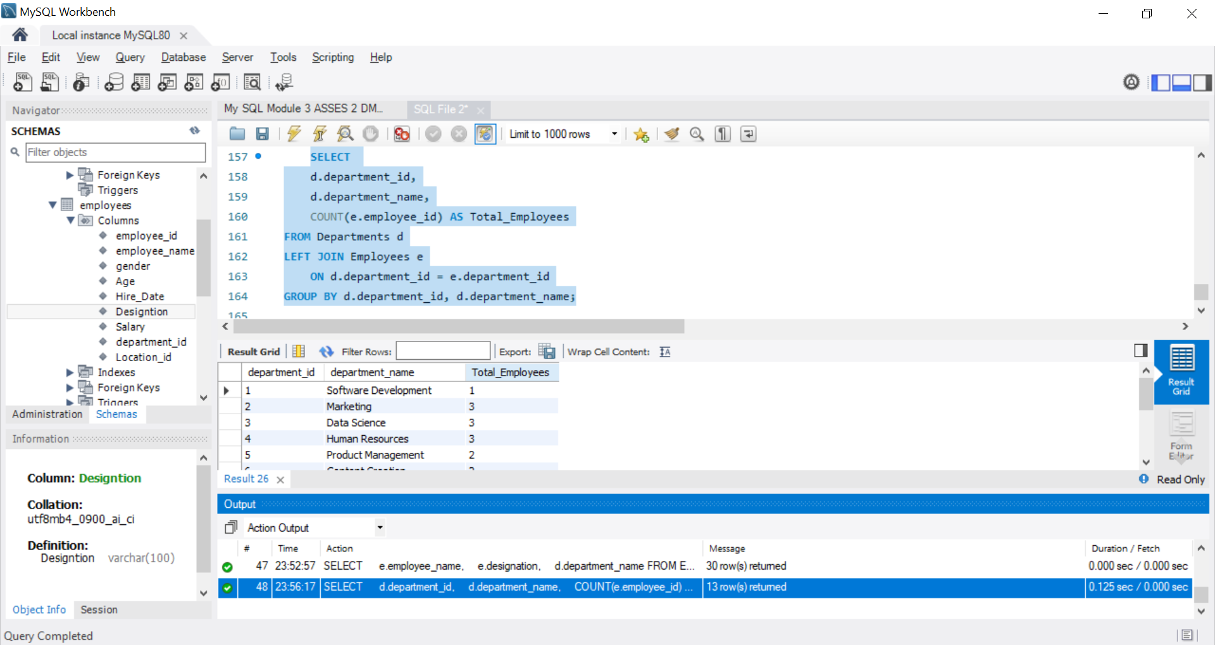
3. RIGHT JOIN:
● Display all locations along with the names of employees assigned to each location.
If no employees are assigned to a location, display NULL for employee name.
- For a RIGHT JOIN, put the Employees table on the left and the location table on the right. This ensures all locations are displayed, even if no employees are assigned.
Syntax:
SELECT
l.location_id,
l.location_name,
e.employee_name
FROM Employees e
RIGHT JOIN location l
ON e.location_id = l.location_id;

OUTPUT:
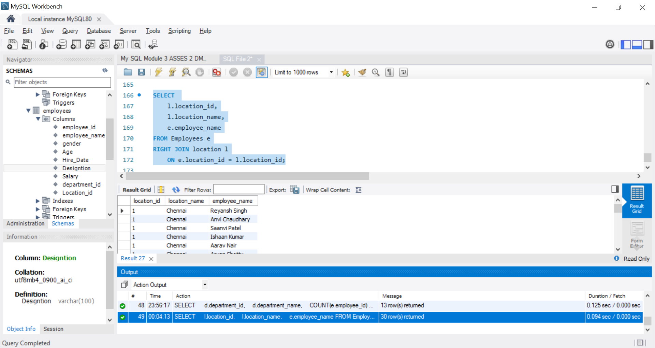
4. CROSS JOIN
● Show all possible combinations of departments and locations.
All possible combinations of departments and locations, use a CROSS JOIN:
Syntax:
SELECT
d.department_id,
d.department_name,
l.location_id,
l.location_name
FROM Departments d
CROSS JOIN location l;
OUTPUT:
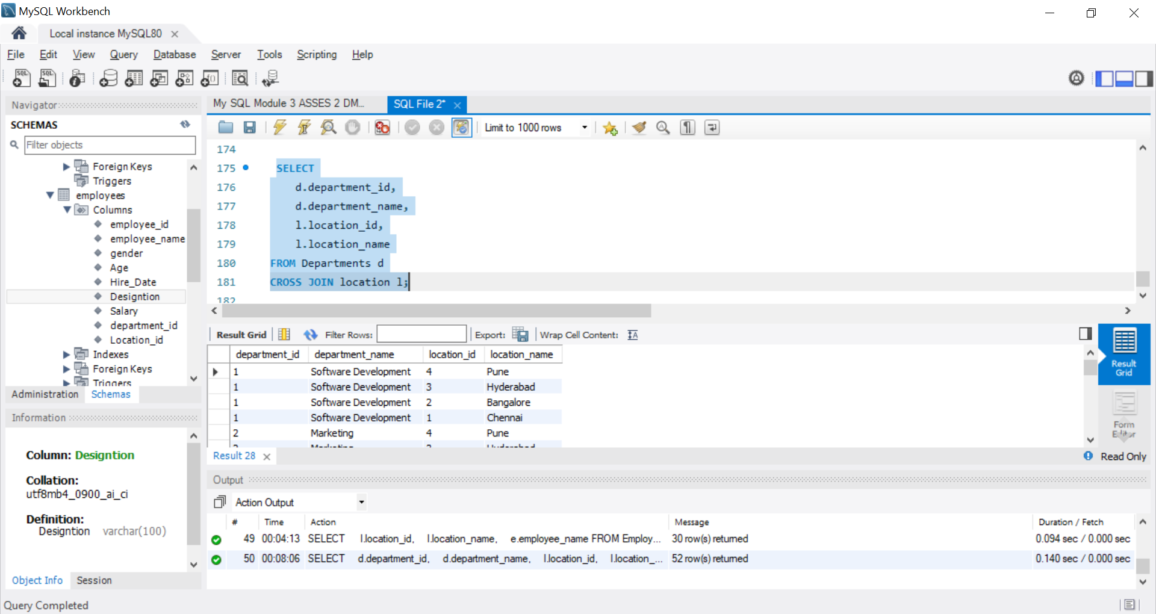
5. SELF JOIN:
● Show pairs of employees working in the same department, excluding self-pairs.
- For a SELF JOIN, join the Employees table to itself using two different aliases:
Syntax:
SELECT
e1.employee_name AS Employee_1,
e2.employee_name AS Employee_2,
e1.department_id
FROM Employees e1
INNER JOIN Employees e2
ON e1.department_id = e2.department_id
AND e1.employee_id < e2.employee_id;

OUTPUT:
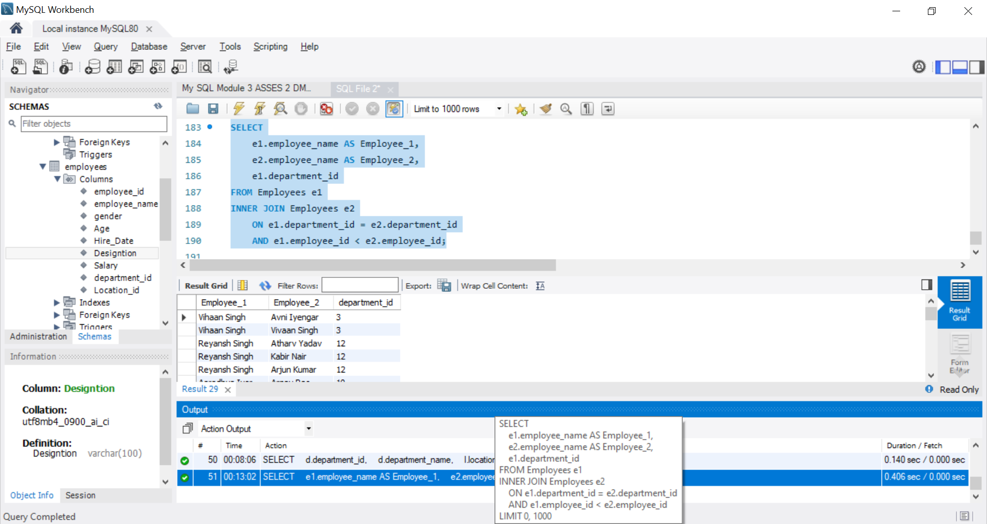

Windows function
● Write a window function query to rank employees by salary using rank().
- Use the RANK() window function to rank employees based on their salary:
Syntax:
SELECT
employee_id,
employee_name,
Salary,
RANK() OVER (ORDER BY Salary DESC) AS Salary_Rank
FROM Employees;

OUTPUT:
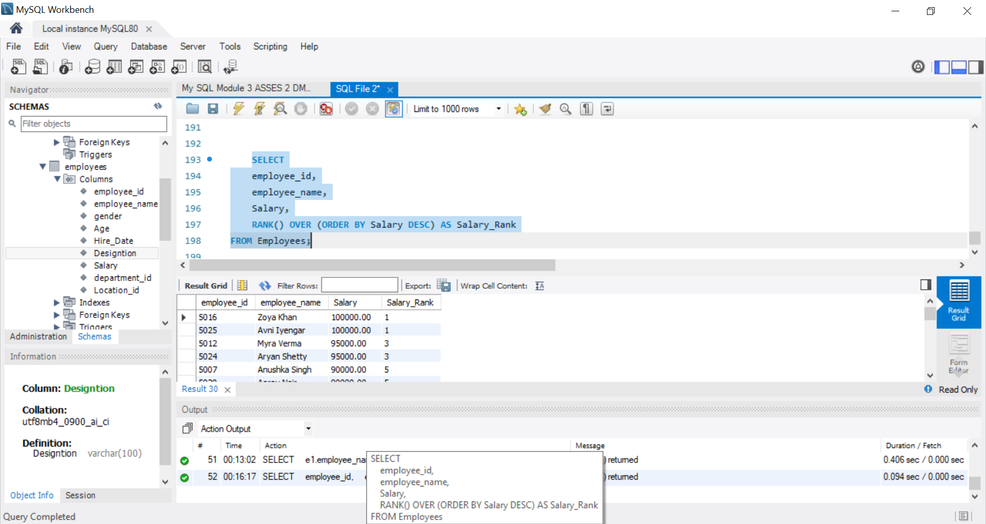

● Write a window function query to rank employees by salary within each department
using DENSE_RANK()
- Use DENSE_RANK() with PARTITION BY department_id to rank employees within each department:
Syntax:
SELECT
employee_id,
employee_name,
department_id,
Salary,
DENSE_RANK() OVER (
PARTITION BY department_id
ORDER BY Salary DESC
) AS Salary_Rank
FROM Employees;

OUTPUT:
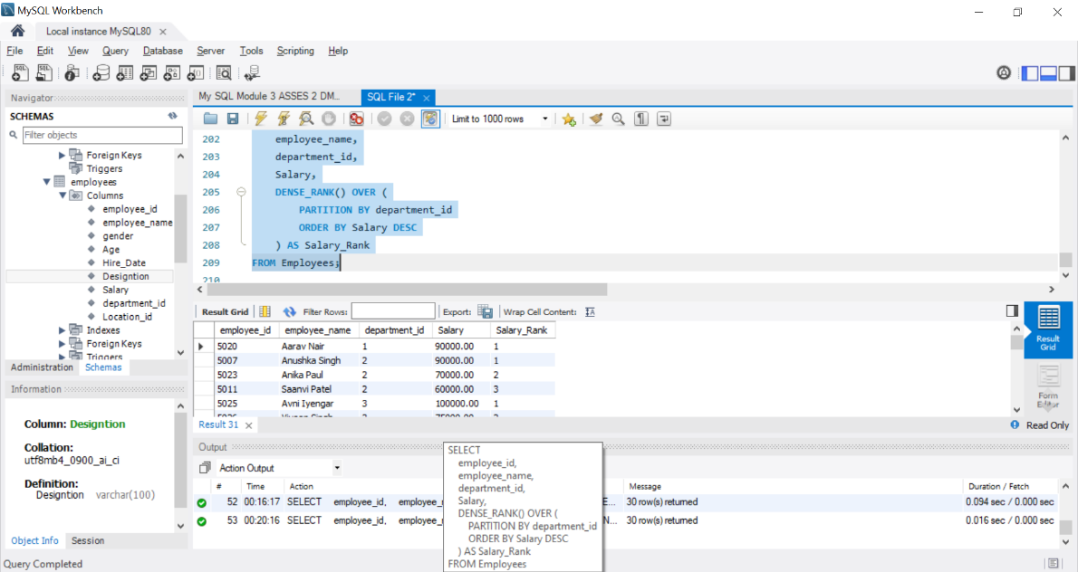
● Write a window function query, Running total salary by department
To calculate a running total of salary within each department, use SUM() as a window function with PARTITION BY
Syntax:
SELECT employee_id,
employee_name,
department_id,
Salary,
SUM(Salary) OVER (
PARTITION BY department_id
ORDER BY employee_id )
AS Running_Total_Salary
FROM Employees;

OUTPUT: 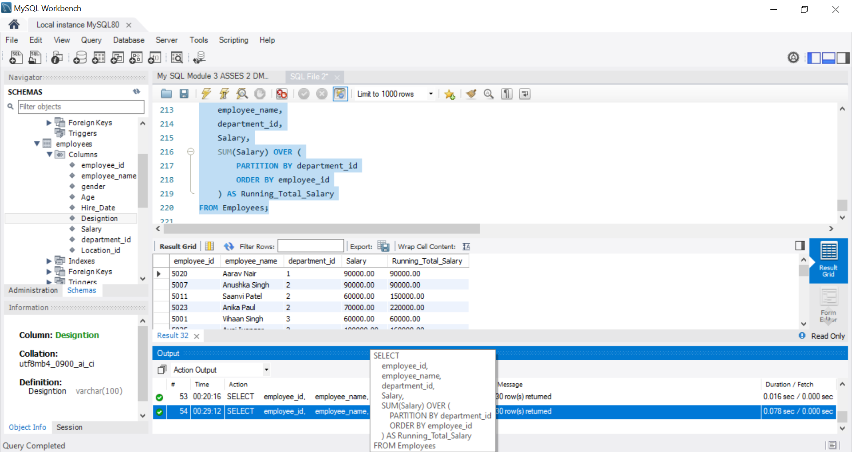
Conclusion
This DML assignment provided practical experience in managing and analyzing employee database records using MySQL. Various SQL commands and techniques were used to insert, retrieve, update, and organize employee data effectively.
The assignment demonstrated the use of INSERT, SELECT, UPDATE, WHERE, DISTINCT, ORDER BY, and LIMIT clauses, along with aggregate functions such as SUM(), MIN(), MAX(), and AVG(). It also covered GROUP BY and HAVING for analyzing employee data based on departments, salaries, and locations.
Different types of joins, including INNER JOIN, LEFT JOIN, RIGHT JOIN, CROSS JOIN, and SELF JOIN, were used to retrieve related information from multiple tables. Window functions such as RANK(), DENSE_RANK(), and running totals were also implemented to perform advanced employee salary analysis.
Overall, this assignment strengthened my understanding of DML operations and SQL data analysis techniques. It demonstrated how MySQL can be used to efficiently retrieve, modify, summarize, and analyse employee information while producing meaningful insights from structured data.

